Group Assignment Week 7
Instructions:
- Each group can pick any of the 2 problems and do the group assignment.
- Any one group member can post the code in the discussion. Even though one member posts the code in the discussion, both group members are eligible for 10 points. To see how to post the code in the discussion, refer to the document ‘How to post code in D2L Discussions’ attached along with the discussion.
- Code should use the Python commands in the code which are covered in the course till this point of time.
Grading Rubric:

Code can be compiled and executed = 3 points

Code complies with assignment instructions = 2 points

Code is giving expected output = 3 points

Comments are written in the code = 2 points

Problem1: Line Numbers
Create a text file named test.txt as shown below. You can use the text editor of your choice. Write 1 to 10 in words in the text file as shown below. Save this file in the same folder as the group assignment Week 7 python file. Write a program that opens this test.txt file in read mode. Then the program should display the contents of the file with each line preceded with a line number followed by a colon.
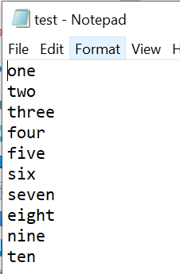
Expected Output:
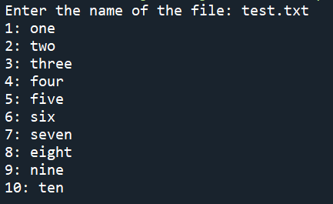
Problem2: Future Value
Suppose you have a certain amount of money in a savings account that earns compound monthly interest, and you want to calculate the amount that you will have after a specific number of months. The formula is as follows:
$$F=P ×{(1+i)}^{t}$$
The terms in the formula are:
- F is the future value of the account after the specified time period
- P is the present value of the account
- i is the monthly interest rate
- t is the number of months
Write a program that prompts the user to enter the account’s present value, monthly interest rate, and the number of months that the money will be left in the account. The program should pass these values to a function that returns the future value of the account, after the specified number of months. The program should display the account’s future value.
Expected Output:
